**IT252 Database Systems Lab Assignment - 1**

**Note:**

• Design, develop, and implement the specified queries for the following problem using MySQL under LINUX environment.

• Create Schema and insert at least 5 records for each table. Add appropriate database constraints.

**Consider the following schema for a Library Database:**

BOOK(Book_id, Title, Publisher_Name, Pub_Year)

BOOK_AUTHORS(Book_id, Author_Name)

PUBLISHER(Name, Address, Phone)

BOOK_COPIES(Book_id, Programme_id, No-of_Copies)

BOOK_LENDING(Book_id, Programme_id, Card_No, Date_Out, Due_Date)

LIBRARY_PROGRAMME(Programme_id, Programme_Name, Address)

**Write SQL queries to**

1. Retrieve details of all books in the library – id, title, name of publisher, authors, number of copies in

each Programme, etc.

2. Get the particulars of borrowers who have borrowed more than 3 books, but from Jan 2017 to Jun 2017.

3. Delete a book in BOOK table. Update the contents of other tables to reflect this data manipulation operation.

4. Partition the BOOK table based on year of publication. Demonstrate its working with a simple query.

5. Create a view of all books and its number of copies that are currently available in the Library.

**Table Creation**

CREATE TABLE PUBLISHER (NAME VARCHAR2 (20) PRIMARY KEY, PHONE INTEGER,

ADDRESS VARCHAR2 (20));

CREATE TABLE BOOK (BOOK_ID INTEGER PRIMARY KEY, TITLE VARCHAR2 (20), PUB_YEAR VARCHAR2 (20), PUBLISHER_NAME REFERENCES PUBLISHER (NAME) ON DELETE CASCADE);

CREATE TABLE BOOK_AUTHORS (AUTHOR_NAME VARCHAR2 (20), BOOK_ID REFERENCES BOOK (BOOK_ID) ON DELETE CASCADE, PRIMARY KEY (BOOK_ID, AUTHOR_NAME));

CREATE TABLE LIBRARY_BRANCH (BRANCH_ID INTEGER PRIMARY KEY, BRANCH_NAME VARCHAR2 (50), ADDRESS VARCHAR2 (50));

CREATE TABLE BOOK_COPIES (NO_OF_COPIES INTEGER, BOOK_ID REFERENCES BOOK (BOOK_ID) ON DELETE CASCADE, BRANCH_ID REFERENCES LIBRARY_BRANCH (BRANCH_ID) ON DELETE CASCADE, PRIMARY KEY (BOOK_ID, BRANCH_ID));

CREATE TABLE CARD (CARD_NO INTEGER PRIMARY KEY);

CREATE TABLE BOOK_LENDING (DATE_OUT DATE, DUE_DATE DATE, BOOK_ID REFERENCES BOOK (BOOK_ID) ON DELETE CASCADE, BRANCH_ID REFERENCES LIBRARY_BRANCH (BRANCH_ID) ON DELETE CASCADE, CARD_NO REFERENCES CARD (CARD_NO) ON DELETE CASCADE, PRIMARY KEY (BOOK_ID, BRANCH_ID, CARD_NO));

**Table Descriptions**

DESC PUBLISHER;

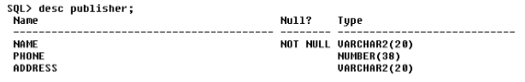

DESC BOOK;

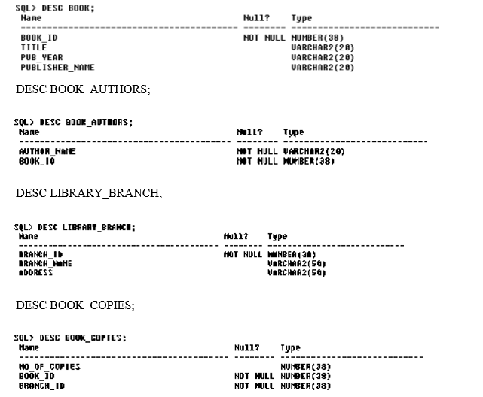

DESC BOOK_LENDING;

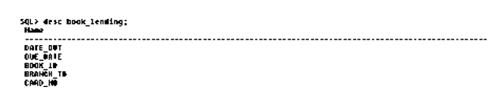

**Insertion of Values to Tables**

INSERT INTO PUBLISHER VALUES (‗MCGRAW-HILL„, 9989076587, ‗BANGALORE„); INSERT INTO PUBLISHER VALUES (‗PEARSON„, 9889076565, ‗NEWDELHI„); INSERT INTO PUBLISHER VALUES (‗RANDOM HOUSE„, 7455679345, ‗HYDRABAD„); INSERT INTO PUBLISHER VALUES (‗HACHETTE LIVRE„, 8970862340, ‗CHENAI„); INSERT INTO PUBLISHER VALUES (‗GRUPO PLANETA„, 7756120238, ‗BANGALORE„);

INSERT INTO BOOK VALUES (1,„DBMS„,„JAN-2017„, ‗MCGRAW-HILL„); INSERT INTO BOOK VALUES (2,„ADBMS„,„JUN-2016„, ‗MCGRAW- HILL„); INSERT INTO BOOK VALUES (3,„CN„,„SEP-2016„, ‗PEARSON„); INSERT INTO BOOK VALUES (4,„CG„,„SEP-2015„, ‗GRUPO PLANETA„); INSERT INTO BOOK VALUES (5,„OS„,„MAY-2016„, ‗PEARSON„);

INSERT INTO BOOK_AUTHORS VALUES („NAVATHE„, 1); INSERT INTO BOOK_AUTHORS VALUES („NAVATHE„, 2); INSERT INTO BOOK_AUTHORS VALUES („TANENBAUM„, 3); INSERT INTO BOOK_AUTHORS VALUES („EDWARD ANGEL„, 4); INSERT INTO BOOK_AUTHORS VALUES („GALVIN„, 5);

INSERT INTO LIBRARY_BRANCH VALUES (10,„RR NAGAR„,„BANGALORE„); INSERT INTO LIBRARY_BRANCH VALUES (11,„RNSIT„,„BANGALORE„); INSERT INTO LIBRARY_BRANCH VALUES (12,„RAJAJI NAGAR„, „BANGALORE„); INSERT INTO LIBRARY_BRANCH VALUES (13,„NITTE„,„MANGALORE„); INSERT INTO LIBRARY_BRANCH VALUES (14,„MANIPAL„,„UDUPI„);

INSERT INTO BOOK_COPIES VALUES (10, 1, 10); INSERT INTO BOOK_COPIES VALUES (5, 1, 11); INSERT INTO BOOK_COPIES VALUES (2, 2, 12); INSERT INTO BOOK_COPIES VALUES (5, 2, 13); INSERT INTO BOOK_COPIES VALUES (7, 3, 14); INSERT INTO BOOK_COPIES VALUES (1, 5, 10); INSERT INTO BOOK_COPIES VALUES (3, 4, 11);

INSERT INTO CARD VALUES (100); INSERT INTO CARD VALUES (101); INSERT INTO CARD VALUES (102);

INSERT INTO CARD VALUES (103);

INSERT INTO CARD VALUES (104);

INSERT INTO BOOK_LENDING VALUES („01-JAN-17„,„01-JUN-17„, 1, 10, 101); INSERT INTO BOOK_LENDING VALUES („11-JAN-17„,„11-MAR-17„, 3, 14, 101); INSERT INTO BOOK_LENDING VALUES („21-FEB-17„,„21-APR-17„, 2, 13, 101); INSERT INTO BOOK_LENDING VALUES („15-MAR-17„,„15-JUL-17„, 4, 11, 101); INSERT INTO BOOK_LENDING VALUES (‗12-APR-17„,„12-MAY-17„, 1, 11, 104); SELECT * FROM PUBLISHER;

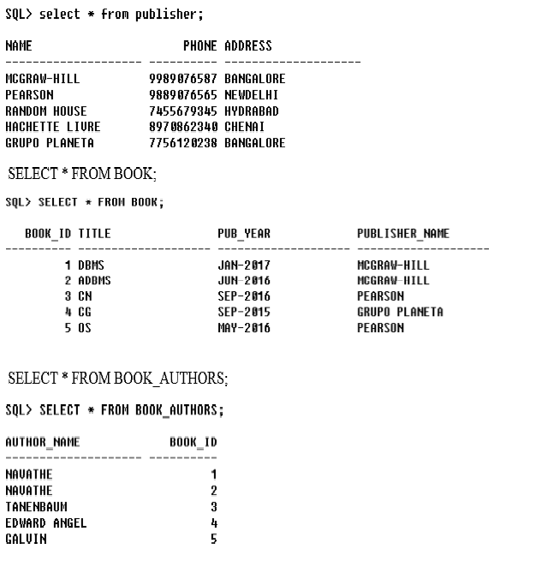

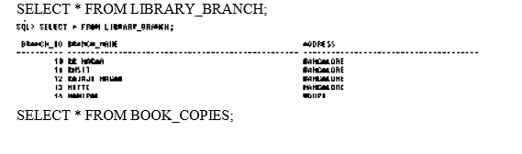

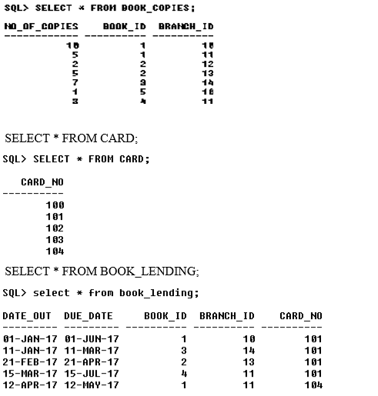

**Queries:**

**1. Retrieve details of all books in the library – id, title, name of publisher, authors, number of copies in each branch, etc.**

SELECT B.BOOK_ID, B.TITLE, B.PUBLISHER_NAME, A.AUTHOR_NAME, C.NO_OF_COPIES, L.BRANCH_ID FROM BOOK B, BOOK_AUTHORS A, BOOK_COPIES C, LIBRARY_BRANCH L WHERE B.BOOK_ID=A.BOOK_ID AND B.BOOK_ID=C.BOOK_ID AND L.BRANCH_ID=C.BRANCH_ID;

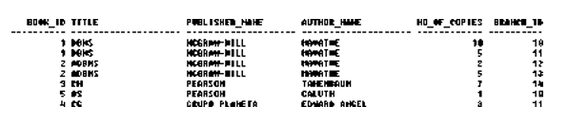

**2. Get the particulars of borrowers who have borrowed more than 3 books, but from Jan 2017 to Jun 2017.**

SELECT CARD_NO FROM BOOK_LENDING WHERE DATE_OUT BETWEEN „01-JAN-2017„ AND „01-JUL-2017„ GROUP BY CARD_NO HAVING COUNT (*)>3;



**3. Delete a book in BOOK table. Update the contents of other tables to reflect this data manipulation operation.**

DELETE FROM BOOK WHERE BOOK_ID=3;

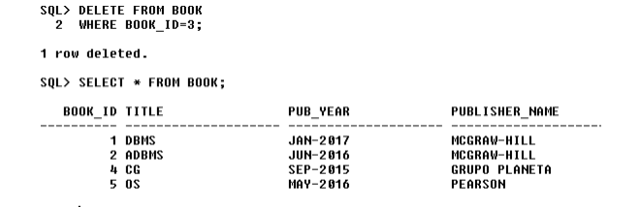

**4. Partition the BOOK table based on year of publication. Demonstrate its working with a simple query.**

CREATE VIEW V_PUBLICATION AS SELECT PUB_YEAR FROM BOOK;

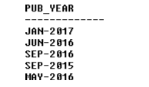

**5. Create a view of all books and its number of copies that are currently available in the Library.**

CREATE VIEW V_BOOKS AS SELECT B.BOOK_ID, B.TITLE, C.NO_OF_COPIES FROM BOOK B, BOOK_COPIES C, LIBRARY_BRANCH L WHERE B.BOOK_ID=C.BOOK_ID AND C.BRANCH_ID=L.BRANCH_ID;

